Bring on the barolo: wine tasting
and truffle hunting in Piedmont
By Jeremy Watson

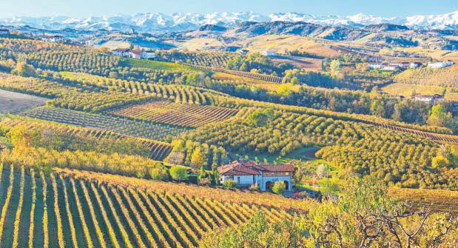
Vineyards near Alba, one of only 11 villages in Italy that are allowed to produce barolo. Below: Watson’s guide, Phil Langford

Jeremy Watson becomes part of the family on a tour of one of northern Italy’s most celebrated wine regions

Fabio Fantino is explaining with ill concealed pride how his grandfather planted the vineyard and his father produced its first wines in the early 1980s. He turns and points to the steep hillside behind, where the dark nebbiolo grapes that make one of northern Italy’s finest barolo reds flourish on rows of vines so impressively precise that Unesco has named this tiny area, around the village of Barolo, a world heritage site.
“I love it that my family has been involved in this right from the start and that I can carry the tradition on,” Fantino says.

I have come to Piedmont with Maestro Tours, a specialist Italian wine tour operator with small-group trips in Sicily, Tuscany and Veneto. The company is run by Phil Langford, an adopted son of Italy who has turned 30 years in the Italian wine business into a passion for showing off the vineyards he treasures the most and the winemakers he now counts as friends.

One thing’s for sure, it pays to have a Langford by your side in Piedmont, a region where wine has been made since before the Roman Empire. Just 11 villages are allowed to produce barolo — counted among the greatest of Italian reds — and Langford is able to open doors there that would otherwise remain firmly shut. Across a week, Langford arranges a series of tastings in atmospheric cellars, such as the one with Fantino. Drinking a glass of fine wine is one thing; discussing its intricacies with the man who made it, and whose grandfather planted the vines is quite another. Eating Fantino’s mother’s bunet — a creamy pudding made
from cocoa, eggs and amaretti — takes it to another level, especially when paired with a rich port-like barolo dessert wine.

While still at Fantino’s winery, we also try the family’s homemade ravioli del plin — stuffed fresh pasta from southern Piedmont — in a glass fronted hilltop building that looks over the vineyard to a broad valley of neat Italian villages framed by the snow-capped Alps. None of us wants to leave: our small party of ten have come to feel part of the family.

Becoming part of the family is a recurring theme of the days to come.
At the Marcarini winery, Manuel Marchetti, whose late wife’s great great-great-grandfather founded the winery in 1850, shows us around his cellar inside a 17th-century tower before taking us through his estate-grown, estate-bottled
range.
At Poderi Luigi Einaudi, we dine and sample wines with the flamboyant owner, Matteo Sardagna, in an architect designed winery ingeniously concealed in a hillside, then stagger to our beds in the luxury guesthouse above.

Between wineries, Langford takes us to tucked-away local restaurants to try Piedmontese specialities that we might not otherwise discover. In fact, throughout the week, there’s a real
sense we’re being given the inside track. At Poderi Colla winery, the owner Tino Colla proudly shows us the museum he has built to display the equipment used by his forefathers. “People spend too much time rushing around now,” he says. “They need to take their time and enjoy what is around them.” He doesn’t say it explicitly but I think he means kick back and enjoy a glass or two of his prized single-estate reds.

Here at Poderi Colla, Langford arranges another treat. Up above the vines is an old oak wood — a prime hunting ground for the world-famous white truffles of Alba, the Piedmontese town at the heart of the forests where the delicacy grows. While some of our party sneak off to a cookery class to master those finicky pasta parcels, I head out with a truffle hunter and his faithful truffle hound, Bea, in search of the knobbly fungi. It is truffle season and Bea eventually sniffs out a prime specimen at the base of a tree. Her master digs into the soil and plucks out a sizeable white truffle with its earthy, garlicky, unmistakable aroma. Langford begins negotiations with the truffle hunter for a sale. Never has double fried egg — my Piedmontese lunch topped with generous shavings of fresh white truffle — tasted so good.

The day after, we pause in Alba to stroll among the sights of truffle town; cobbled streets, twisting alleyways, lofty clock towers on ancient churches and market stalls displaying locally harvested hazelnuts and pleasingly gooey nougat. The pungent smell of the truffle leaks from the doorways of the delicatessens and wine shops lining the Via Vittorio Emanuele I.

Langford says he enjoys revealing the pleasures of this epicurean playground to others of a like mind.
Having drunk the wine, eaten the truffles, revelled in the surroundings and, above all, met the people who live and work there, we all see why.

After six nights in wine heaven, I tag on an overnight stay at the Melia Milano, an elegant, boutique style hotel in the city’s booming Zona Lotto, an easy 15-minute metro ride from the Duomo. The 600-year old cathedral is one of my all-time favourite views but, reclining in the
sun in a pavement café with a glass in my hand, I can’t help hankering for Piedmont.

